

www.globalsight.com

**SmartBox Specification**

Open source initiative for

managing, translating &

delivering global content

Contents

Background & Requirement 3

Function Design 3

Processing Logic 5

Log files: 6

Appendix A: GSSmartBox.conf 7

Appendix B: 9

# Background & Requirement

Smartbox is a convenient standalone application which is used to send files to GlobalSight and get target files from GlobalSight. Its main functionality is familiar with DesktopIcon application.

Default, it will create one job per file. For zip files, all files in one zip will be created in one job. So if user wants multiple files to be in one job, all the files need to be packaged into one zip. For unzipped file, if it has not correct configurations such as file profile mapping etc, this file will not be imported to GlobalSight. For zip files, only files with correct file profile mapping in GSSmartBox.conf will be processed, un-correct mapping files will be ignored, they will not block the job creating.

# Function Design

The main process road is like below, also refer to notes in “GSSmartBox.conf” file in appendix A.

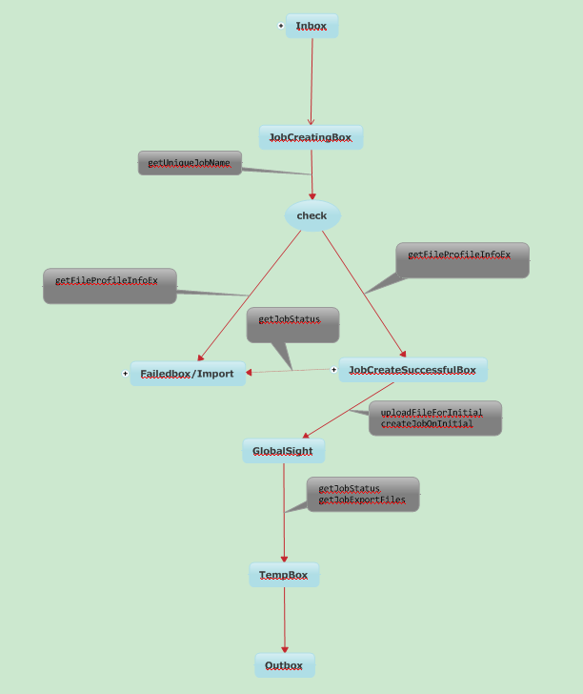

## Processing Logic

1. **Inbox:**

User sends source files into “inbox” manually, or via FTP, SMB.

Note that Smartbox only cares files in “inbox”, not care sub folders in “inbox” for now. In another words, files in inbox\sub folders will be ignored.

1. **inbox4XLZ:**

This inbox is only for XLZ or XLIFF files. SmartBox will try to parse XLIFF file to get its “source-language” and “target-language”, and pick up a corresponding file profile from “fileProfileConfiguration”, then create job which has only one workflow that matches “target-language”.

1. **JobCreatingBox:**

Smartbox cuts source files that have finished writing into inbox into this folder. For zip file, it will be unzipped here.

Check if file profile mapping configuration is fine via web service API: *getFileProfileInfoEx()*. If not mapping correctly, the source files will be cut into “**FailedBox**”; If fine, source files will be cut into **JobCreateSuccessfulBox.**

1. **FailedBox:**

Source files in JobCreatingBox that have no correct file profile mapping will be cut into this box.

If job creating fails, the source files will be cut into this box from JobCreateSuccessfulBox.

1. **JobCreateSuccessfulBox**

Source files in this box will be sent to GlobalSight to create jobs. Web service APIs used are*getUniqueJobName(), uploadFileForInitial() and createJobOnInitial().*

After jobs are sent to GlobalSight, Smartbox will check if the job creating is finished in configured time interval “FileCheckToCreateJobTime” via API *getJobStatus().* If fail, the source files will be cut into “FailedBox” so that user can check which files are failed to create jobs.

1. **TempBox:**

This box is used to store downloaded target files for temp usage. Every “DownloadCheckTime” interval, Smartbox will check if there are target files that can be downloaded via API *getJobStatus(),* if can download, it gets downloadable information via API *getJobExportFiles()* for real downloading.

1. **OutBox:**

When the downloading is finished, target files will be cut into this box, user can get these files via FTP, SMB or manually.

## Log files:

There are 5 log files in Smartbox.

**failed.log**: all log info about failures, such as file profile mapping failure, job creating fail etc.

**GSSmartBox.log**: common SmartBox info.

**jobCreating.log**: source files list which are being in job creating.

**jobCreateSuccessful.log**: source files list which have created jobs successfully.

**jobs.log**: job ID, name, status for all jobs.

## Appendix A: GSSmartBox.cfg.xml

<CompanyConfiguration>

<!-- Company Name -->

<company>Terex</company>

<!-- All diectory path should use "/" i.e //10.10.215.141/welocalize or C:/GSSmartBox/welocalize or /home/leon/Desktop/welocalize. BaseDir is an existing directory to save files -->

<baseDir>C:/GSSmartBox/Terex</baseDir>

<fileboxes>

<!-- Inbox directory is used for storing source files from user, only one path is allowed.

inbox4XLZ directory is used for xlz files which will overwrite the SourceLocale and TargetLocale.

Outbox directory is used for storing exported files for user

FailedBox is used for storing source files of failed job, user can handLing these files and copy these file to inbox

JobCreateSuccessfulBox is used for storing source files of successful jobS

JobCreatingBox is used for storing temp files during creating job

TempBox is used for saving temp files -->

<inbox>Inbox</inbox>

<inbox4XLZ></inbox4XLZ>

<jobCreatingBox4XLZ></jobCreatingBox4XLZ>

<outbox>Outbox</outbox>

<jobCreatingBox>JobCreatingBox</jobCreatingBox>

<jobCreateSuccessfulBox>JobCreateSuccessfulBox</jobCreateSuccessfulBox>

<failedBox>Failedbox</failedBox>

<tempBox>TempBox</tempBox>

</fileboxes>

<!-- ProcessCase for this company -->

<preProcessClass>com.globalsight.smartbox.bussiness.process.GeneralPreProcess</preProcessClass>

<postProcessClass>com.globalsight.smartbox.bussiness.process.GeneralPostProcess</postProcessClass>

<!-- GlobalSight host, port, https(on, off) -->

<webClient>

<host>10.10.215.127</host>

<port>80</port>

<https>off</https>

<username>comadmin</username>

<password>password</password>

</webClient>

<checkTimer>

<!-- Time interval to check the files to create job, in seconds -->

<fileCheckToCreateJobTime>120</fileCheckToCreateJobTime>

<!-- Time interval to download jobs, in seconds -->

<downloadCheckTime>120</downloadCheckTime>

<jobSuccessfulCheckTime>30</jobSuccessfulCheckTime>

</checkTimer>

<!-- Source Locale configuration(NOTE THAT ONLY ONE LOCALE IS ALLOWED) -->

<sourceLocale>en_US</sourceLocale>

<!-- Target Locale configuration(MULTIPLE LOCALES ARE ALLOWED, SEPARATED BY COMMA) -->

<targetLocale>fr_FR,de_DE</targetLocale>

<ftpConfig>

<!-- FTP configuration(UseFTP= yes or no) if you have set inbox4XLZ attribute ,it will auto create inbox4XLZ at the same Directory as inbox -->

<useFTP>false</useFTP>

<ftpHost>ftp.beijing.welocalize.com</ftpHost>

<ftpUsername></ftpUsername>

<ftpPassword></ftpPassword>

<ftpPort>21</ftpPort>

<ftpInbox>/GlobalSight/leon/inbox</ftpInbox>

<ftpOutbox>/GlobalSight/leon/outbox</ftpOutbox>

<ftpFailedbox>/GlobalSight/leon/failedbox</ftpFailedbox>

</ftpConfig>

<smbConfig>

<!-- SMB configuration(UseSMB= yes or no), SMB used for remote share in Linux -->

<useSMB>false</useSMB>

<SMBServerHost>10.10.215.109</SMBServerHost>

<SMBUsername>leon</SMBUsername>

<SMBPassword>password</SMBPassword>

<SMBInbox>/share/inbox/</SMBInbox>

<SMBOutbox>/share/outbox/</SMBOutbox>

<SMBFailedbox>/share/failedbox/</SMBFailedbox>

</smbConfig>

<!-- File Profile configuration:ExtensionToFileProfile, if one file profile has multiple extenstions. -->

<extension2fp>

<property fpName="html" extension="html,htm" />

<property fpName="txt" extension="txt" />

</extension2fp>

</CompanyConfiguration>

## Appendix B:

This section is experimental. Its goal is to give QA a better understanding of what areas of the product are affected by a change.

Below is an image of SmartBox components, divided up by how they work and the file moved.

